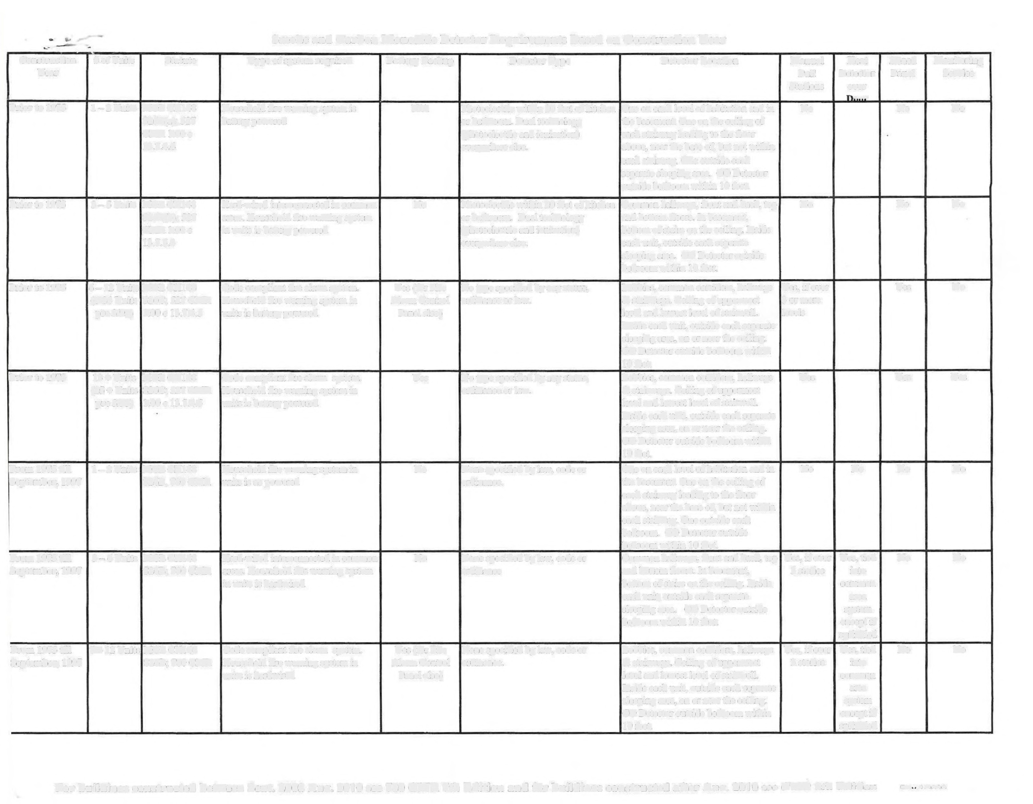Smoke and Carbon Monoxide Detector Requirements Based on Construction Year

Construction # of Units Statute Type of system required Battery Backup Detector Type Detector Location Manual Heat Zoned Monitoring
Year Pull Detector Panel Service
Stations over
+
Prior to 1975 1-2Units MGLCH148 Household fire warning system is NIA Photoelectric within 20 feet of kitchen One on each level of habitation and in No No No
S26E(a); 527 battery powered or bathroom. Dual technology the basement. One on the ceiling of
CMR I.00c (photoelectric and ionization) each stairway leading to the floor
13.7.4.6 everywhere else. above, near the base of, but not within each stairway. One outside each separate sleeping area. CO Detector outside bedroom within IO feet.
Prior to 1975 3--5Units MGL CH148 Hard-wired interconnected in comm on No Photoelectric within 20 feet of kitchen Common hallways, front and back, top No No No
26E(b); 527 areas. Household fire warning system or bathroom. Dual technology and bottom floors. In basement,
CMR 1.00c in units is battery powered (photoelectric and ionization) bottom of stairs on the ceiling. Inside
13.7.5.4 everywhere else. each unit, outside each separate sleeping area. CO Detector outside bedroom within 10 fect.
Prior to 1975 6- 12 Units MGLCH148 Code compliant fire alarm system. Yes (for Fire No type specified by any statue, Lobbies, common corridors, hallways Yes, if over Yes No
(6-24 Units S26C; 527 CMR Household fire warning system in Alarm Control ordinance or law. & stairways. Ceiling of uppermost 3 or more
pre 3/95) l.00c 13.7.4.5 units is battery powered Panel also) level and lowest level of stairwell. levels Inside each unit, outside each separate sleeping area, on or near the ceiling.
CO Detector outside bedroom within
10 feet.
Prior to 1975 13 + Units MGLCH148 Code compliant fire alarm system. Yes No type specified by any statue, Lobbies, comm on corridors, hallways Yes Yes Yes
(25 + Units S26C; 527 CMR Household fire warning system in ordinance or law. & stairways. Ceiling of uppermost
pre 3/95) 1.00 C 13.7.4.5 units is battery powered level and lowest level of stairwell.
Inside each unit, outside each separate sleeping area, on or near the ceiling. CO Detector outside bedroom within
10 feet.
From 1975 till 1-2Units MGLCHl48 Household fire warning system in No None specified by law, code or One on each level of habitation and in No No No No
September, 1997 $26B, 780 CMR units is ac powered ordinance. the basement. One on the ceiling of each stairway leading to the floor above, near the base of, but not within each stairway. One outside each bedroom. CO Detector outside bedroom within 10 feet.
From 1975 till 3-6Units MGLCHl48 Hard-wired interconnected in common No None specified by law, code or Common hallways, front and back, top Yes, if over Yes, tied No No
September, 1997 $26B; 780 CMR areas. Household fire warning system ordinance and bottom floors. In basement, 3 stories into
in units is hardwired bottom of stairs on the ceiling. Inside common each unit, outside each separate area sleeping area. CO Detector outside system bedroom within IO feet. except if
sprinkled
From 1975 till 712 Units MGLCH148 Code compliant fire alarm system. Yes (for Fire None specified by law, code or Lobbies, common corridors, hallways Yes, if over Yes, tied No No
September, 1997 $26B; 780 CMR Household fire warning system in Alarm Control ordinance. & stairways. Ceiling ofuppennost 3 stories into units is hardwired Panel also) level and lowest level of stairwell. common
Inside each unit, outside each separate area sleeping area, on or near the ceiling. system CO Detector outside bedroom within except if
10 feet. sprinkled

For buildings constructed hetween Sent. 2008 Au9. 2010 see 780 CMR 7th Edition and for buildinos constructed after Ano. 2010 eee CM Rth Fi+ion D«diet
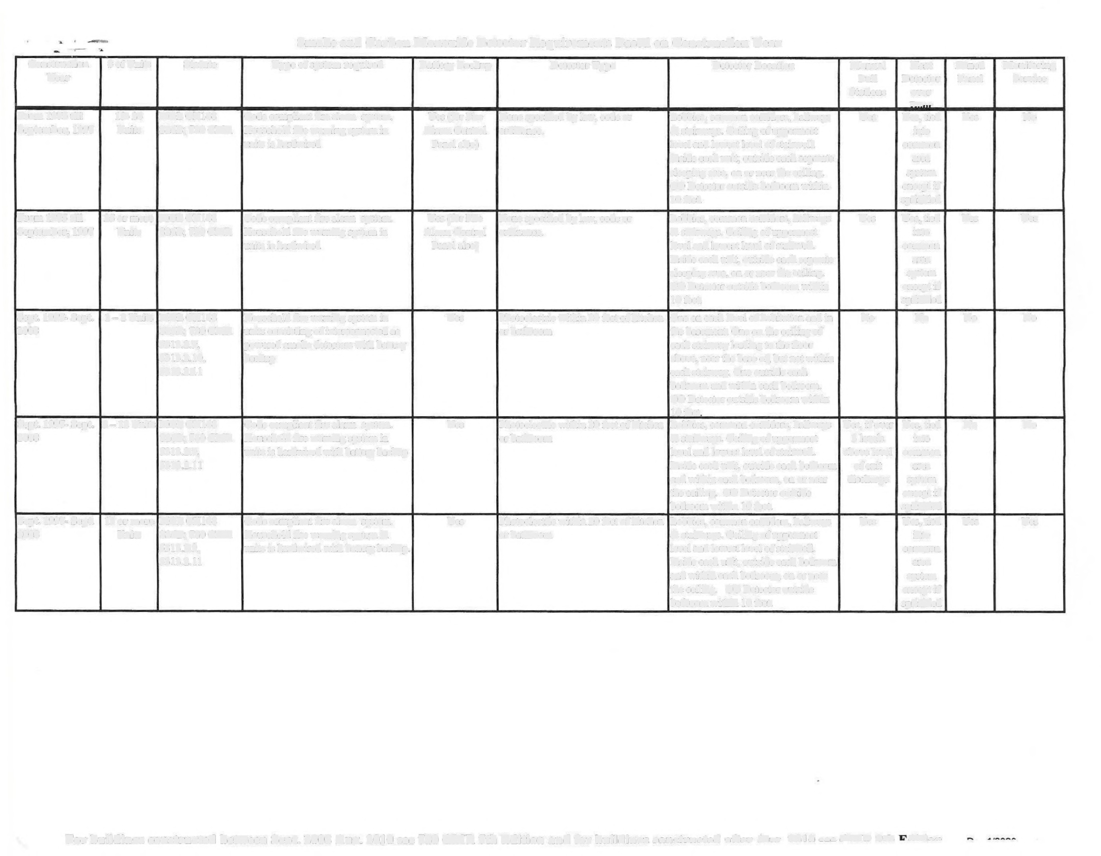Smoke and Carbon Monoxide Detector Requirements Based on Construction Year

Construction # of Units Statute Type of system required Battery Backup Detector Type Detector Location Manual Heat Zoned Monitoring
Year Pull Detector Panel Service
Stations over no
From 1975 till 13- 24 MGLCH148 Code compliant fire alarm system. Yes (for Fire None specified by law, code or Lobbies, common corridors, hallways Yes Yes, tied Yes No
September, 1997 Units S26B; 780 CMR Household fire warning system in Alarm Control ordinance. & stairways. Ceiling of uppermost into units is hardwired Panel also) level and lowest level of stairwell. common
Inside each unit, outside each separate area
sleeping area, on or near the ceiling. system
CO Detector outside bedroom within except if
10 feet. sprinkled

From 1975 till 25 or more MGLCHJ48 Code compliant fire alarm system. Yes (for Fire None specified by law, code or Lobbies, common corridors, hallways Yes Yes, tied Yes Yes
September, 1997 Units S26B; 780 CMR Household fire warning system in Alann Control ordinance. & stairways. Ceiling of uppermost into units is hardwired Panel also) level and lowest level of stairwell. common
lnside each unit, outside each separate area sleeping area, on or near the ceiling. system CO Detector outside bedroom within except if IO feet. sprinkled
Sept. 1997- Sept. 1-2Units MGLCHl48 Household fire warning system in Yes Photoelectric within 20 feet of kitchen One on each level of habitation and in No No No No
2008 S26B; 780 CMR units consisting of interconnected ac or bathroom the basement. One on the ceiling of
5313.2.9, powered smoke detectors with battery each stairway leading to the floor
5313.2.10, backup above, near the base of, but not within
5313.2.11 each stairway. One outside each bedroom and within each bedroom. CO Detector outside bedroom within IO feet
Sept. 1997- Sept. 3-12 Units MGLCHl48 Code compliant fire alarm system. Yes Photoelectric within 20 feet of kitchen Lobbies, common corridors, hallways Yes, if over Yes, tied No No
2008 S26B; 780 CMR Household fire warning system in or bathroom & stairways. Ceiling of uppermost 3 levels into
5313.2.9, units is hardwired with battery backup level and lowest level of stairwell. above level common
5313.2.11 Inside each unit, outside each bedroom of exit area and within each bedroom, on or near discharge system the ceiling. CO Detector outside except if bedroom within LO feet. sprinkled
Sept, 1997- Sept. 13 or more MGL CH148 Code compliant fire alarm system. Yes Photoelectric within 20 feet of kitchen Lobbies, common corridors, hallways Yes Yes, tied Yes Yes
2008 Units $26B; 780 CMR Household fire warning system in or bathroom & stairways. Ceiling of uppermost into
5313.2.9, units is hardwired with battery backup. level and lowest level of stairwell. common
5313.2.11 Inside each unit, outside each bedroom area and within each bedroom, on or near system the ceiling. CO Detector outside except if bedroom within 10 feet. sprinkled

For buildings constructed between Sent. 2008 Au9. 2010 see 780 CMR 7th Edition and far hnildinos constructed after A a 010 e 6 6 CD 9+ u:a.

